

Department of Electrical Engineering

Sukkur institute of Business Administration University

**ESE-411: Industrial Electronics**

**Lab 9: Time Control System**

Instructor: Dr. A. A. Shah

|  |  |
| --- | --- |
| Submission profile | |
| Student’s Name: | Submission date: _____, ______, 2019 |
| CMS ID#: | Instructor’s signature: |

|  |  |  |  |  |  |
| --- | --- | --- | --- | --- | --- |
| **Lab Report Rubrics**  (Add the points in each column, then add across the bottom row to find the total score) | | | | | **Total Marks** |
| S.No | **Criterion** | **0.5** | **0.25** | **0.125** |
| 1 | Accuracy | * Desired output | * Minor mistakes | * Critical mistakes |
| 2 | Timing | * Submitted within the given time | * 1 day late | * More than 1 day late |

# Lab Learning Objectives:

After completing this session, student should be able to:

* Design the basic logic functions
* Design the PLC based Mux De Mux
* Develop Oscillator based on PLCs

# Lab Hardware and Software Required:

# 1.Simati Manager

# 2.S7-1200/300

# 3.Desktop/Laptop Computer

**Activity 1**



This program is designed to indicate how many parts per minute pass a given process point. When the start switch is closed, both the counter and timer are enabled. The counter is pulsed for each part passing the sensor. The counting begins and the timer starts timing through its 1-min time interval. At the end of 1 min, the timer done bit causes the counter rung to go false. Sensor pulses continue but do not affect the PLC counter. The number of parts for the past minutes are represented by the accumulated value of the counter.

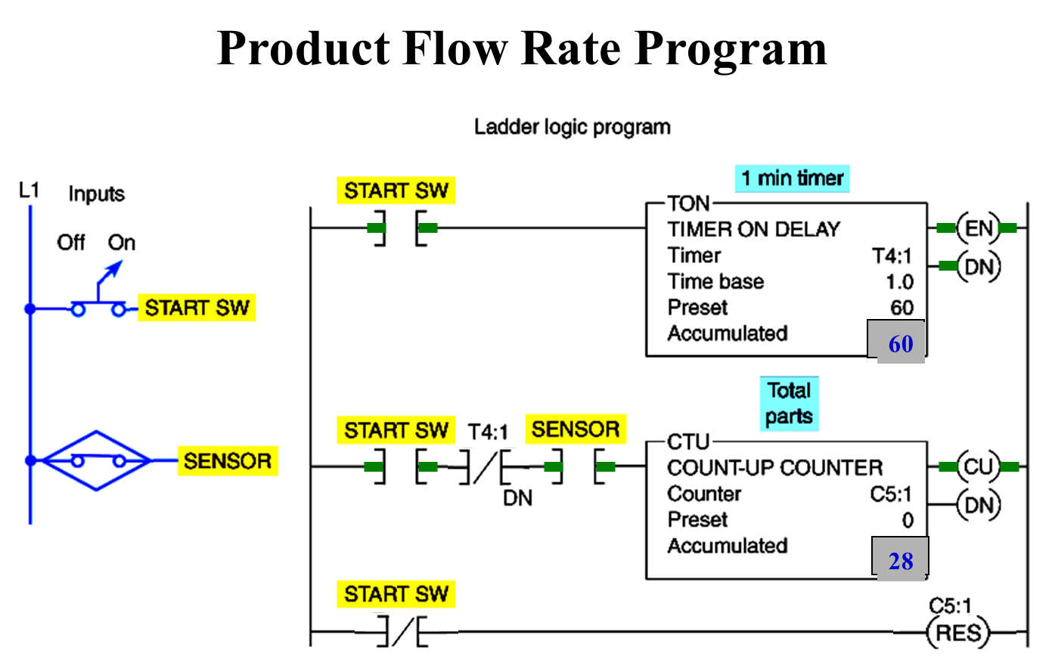

**Activity 2**

Annunciator can be a bell, light, or other device that provides information on the state or condition of something by indicating which of several electric circuits has been activated

Two timers can be interconnected to form an oscillator circuit. The oscillator logic is basically a timing circuit programmed to generate periodic output pulses of any duration. They can be used as part of an annunciator system to indicate an alarm condition.

The oscillator circuit output is programmed in series with the alarm condition. If the alarm condition is true, the appropriate output indicating light will flash. The logic diagrame shown below, please implement it on S7-1200 PLC and Logosot.



**Activity 3**

**Bearing lubrication program**

To start the machine, the operator turns SW on. Before the motor shaft starts to turn, the bearings are supplied with oil by the pump for 10 s. The bearings also receive oil when the machine is running. When the operator turns SW off to stop the machine, the oil pump continues to supply oil for 15 s. A retentive timer is used to track the total running time of the pump. When the total running time is 3 h, the motor is shut down and a pilot light is turned on to indicate that the filter and oil need to be changed. A reset button is provided to reset the process after the filter and oil have been changed.



**Lab Exercise**

Q1. Enter the circuit shown in Activity 1 and attach it.

Q2. Enter the circuit shown in Activity 2 and attach it.

Q3. Enter the circuit shown in Activity 3 and attach it.

**Q4.**  Implement the following Cascading timer program on logosoft. And attach the result



Q5. Write a Program for PLC S1200 based on below figure.

